Module 2 Assignment

1. Register to Netlify

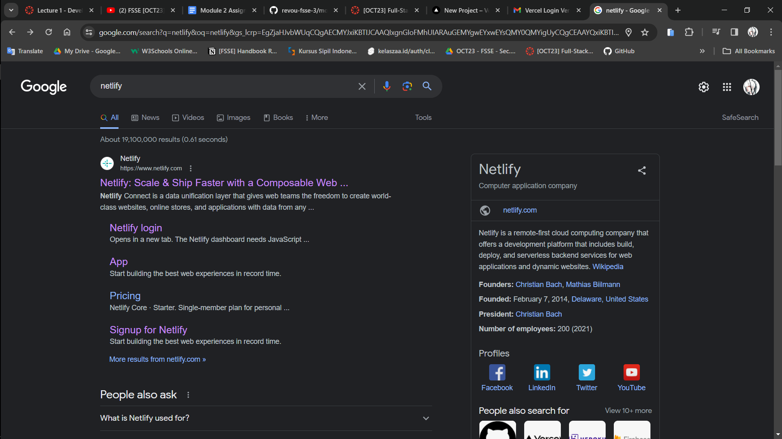

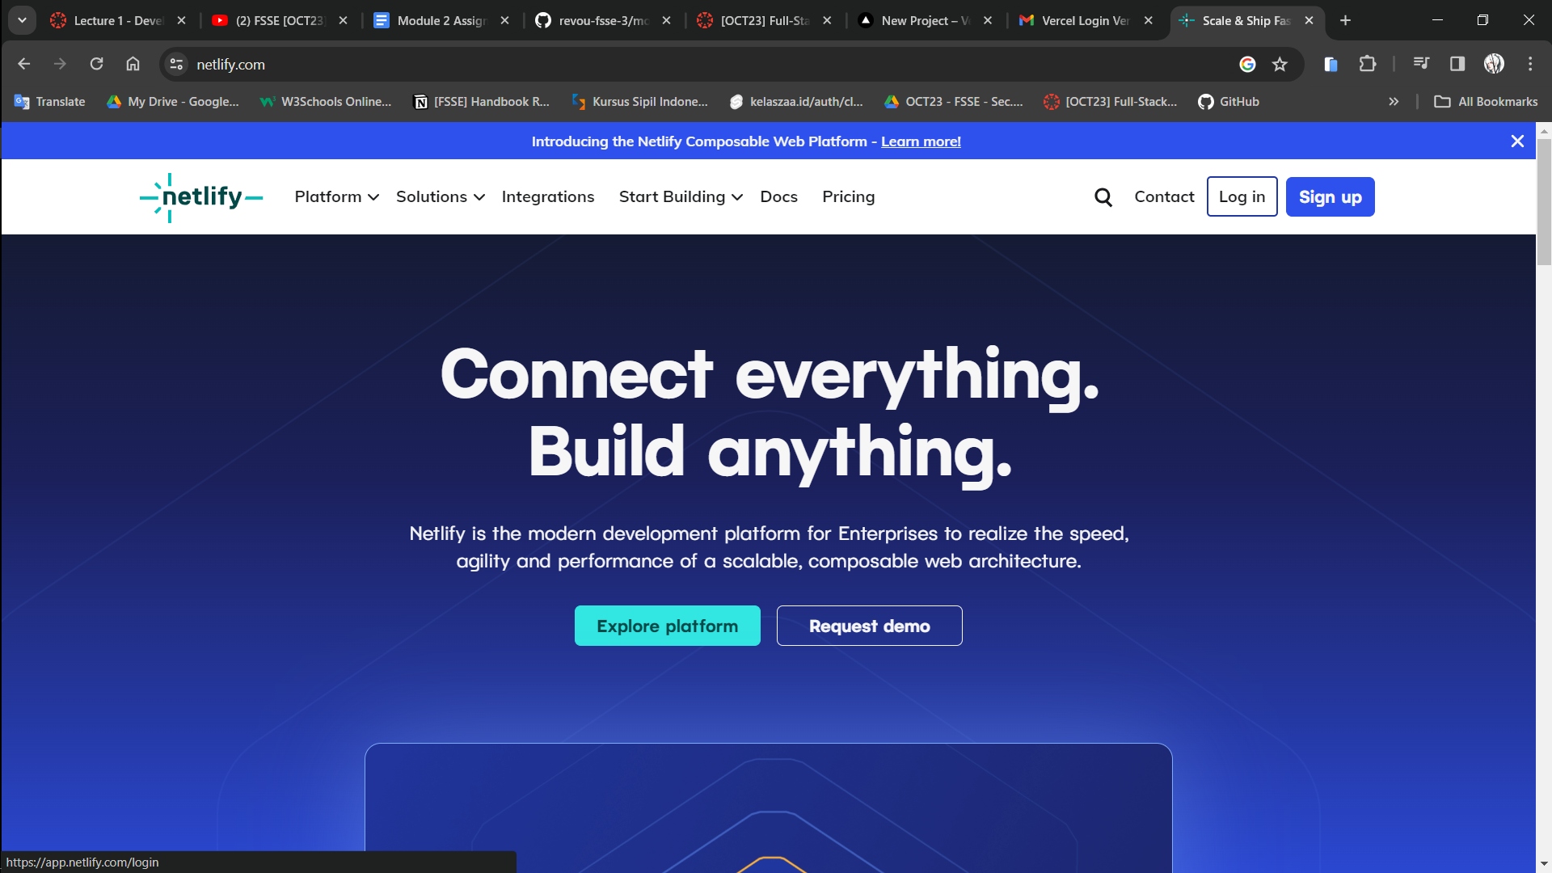

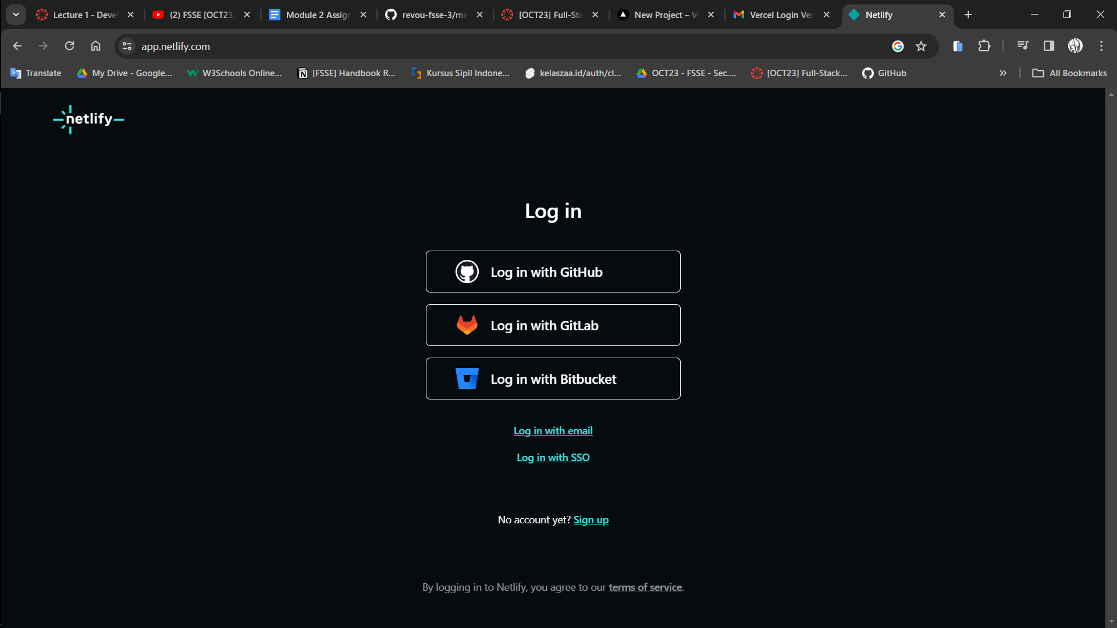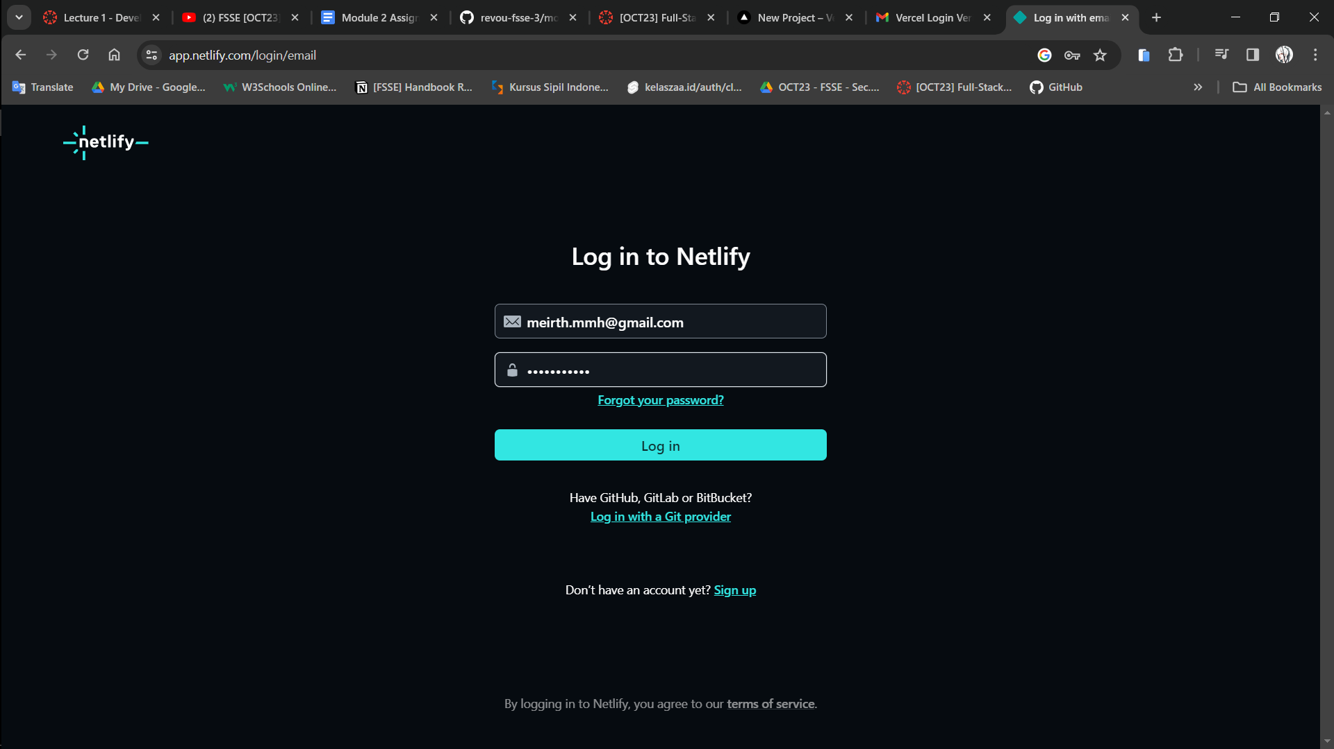 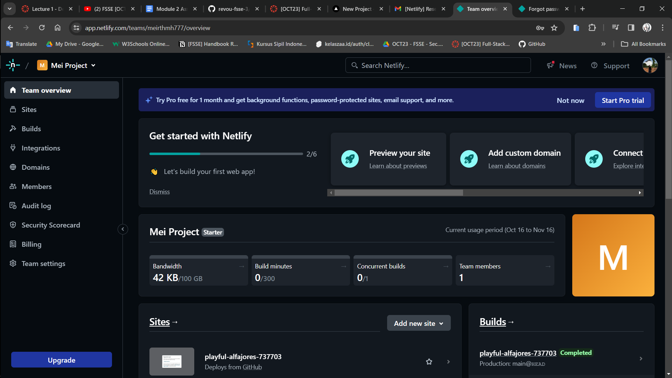

1. Connect the vercel with github repository, deploy the project to vercel and test deployment with create a pull request to main branch and merge it after that.
2. Connect Vercel to Github repository

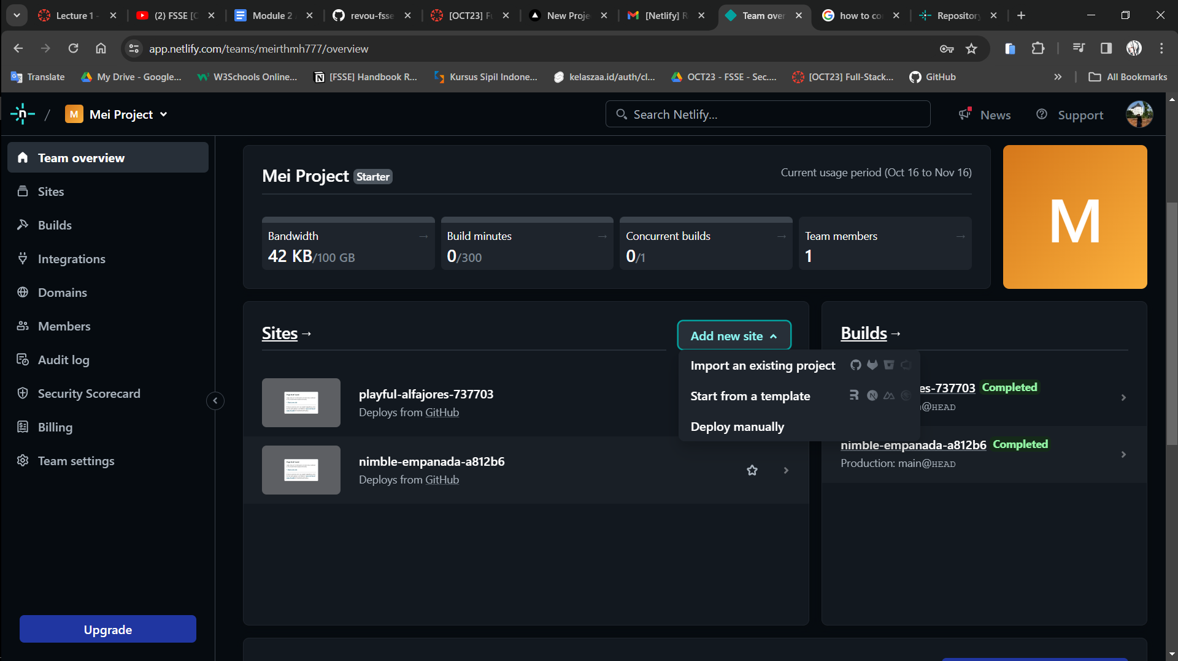

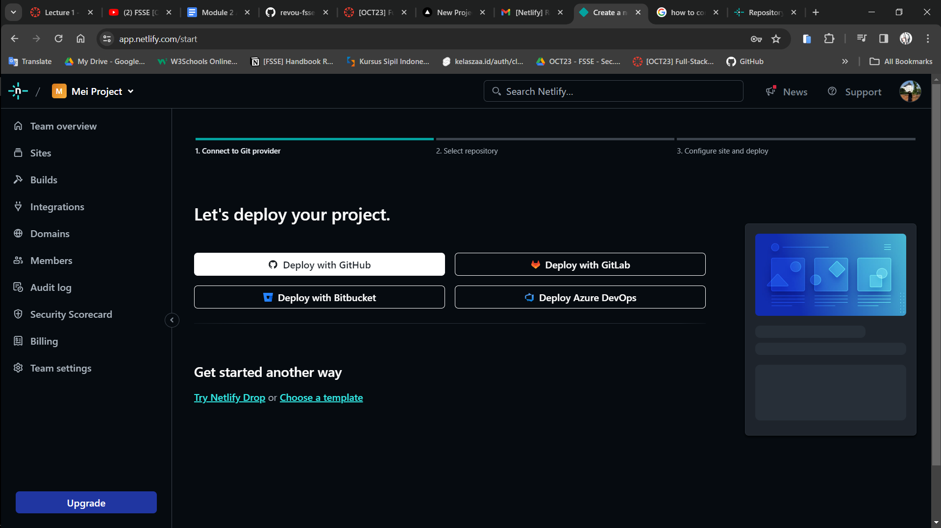

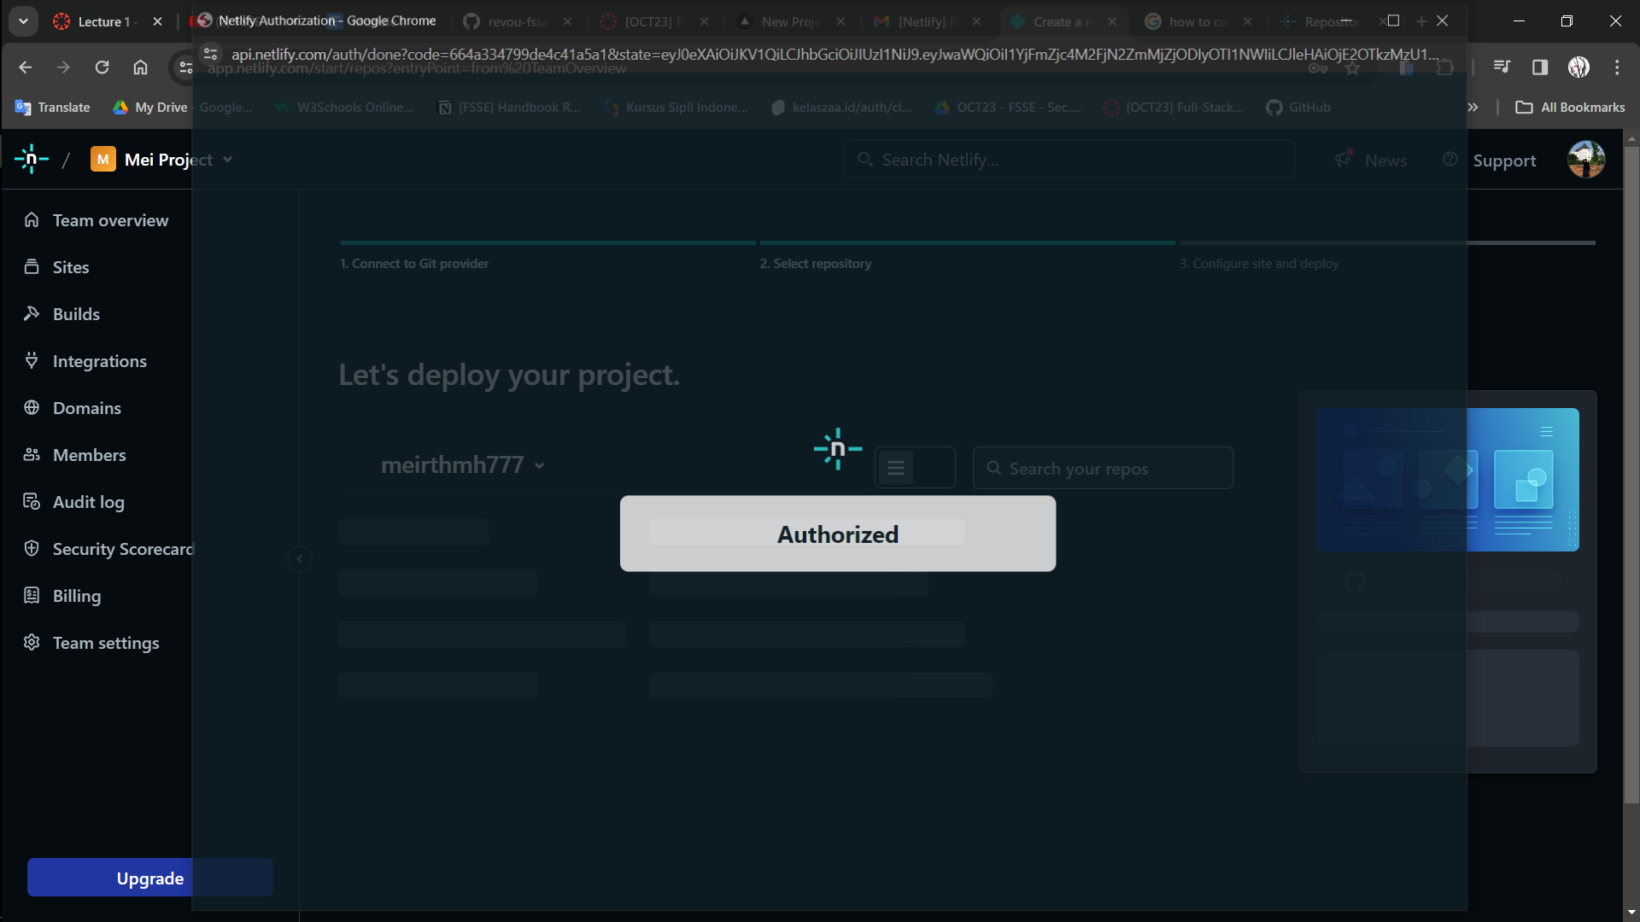

1. Deploy your project to netlify

Choose which github repository you want to connect with Netlify.

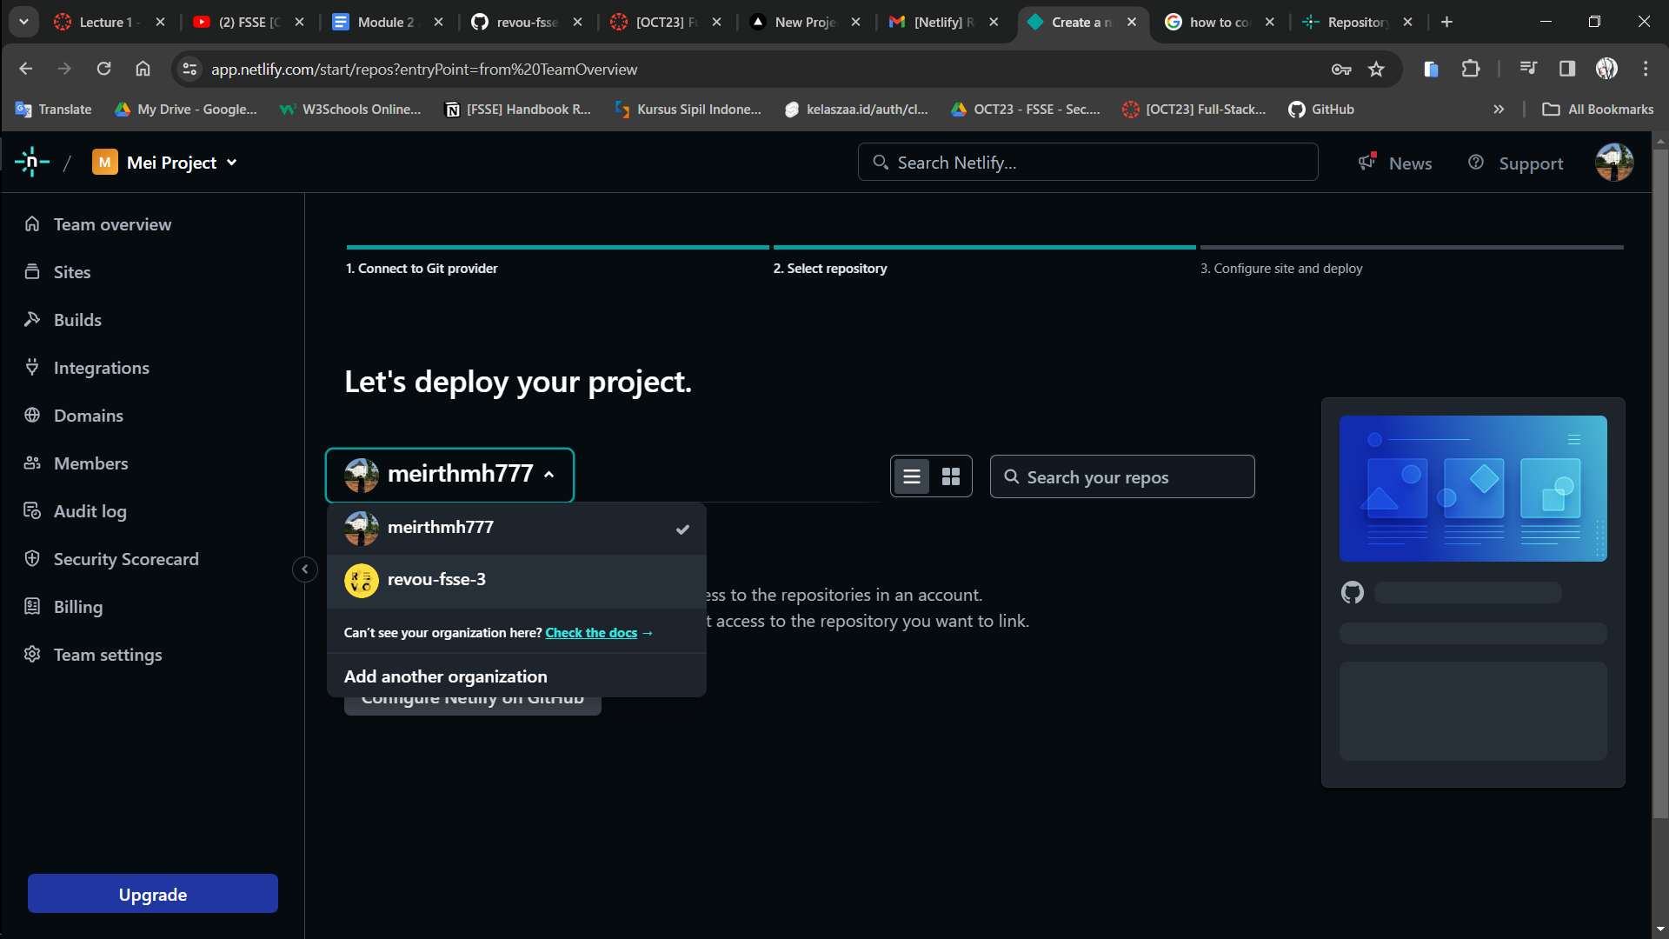

I choose module-2-meirthmh777

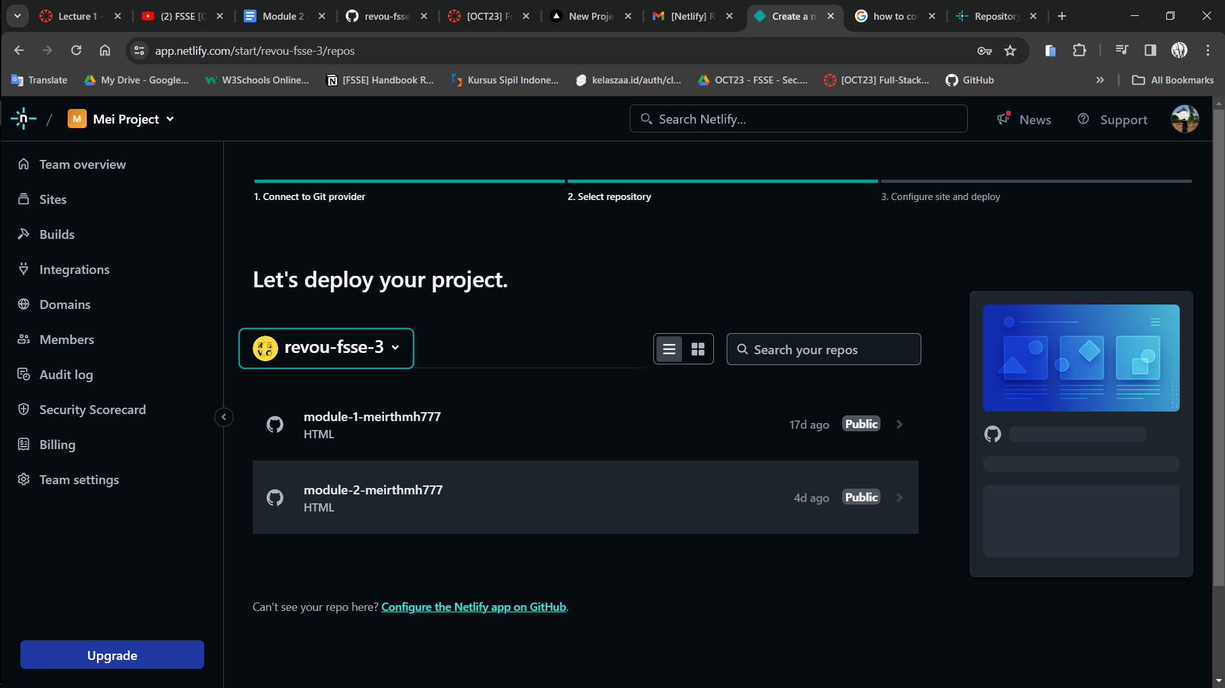

If this page appears, you can scroll down and click on deploy your github repository.

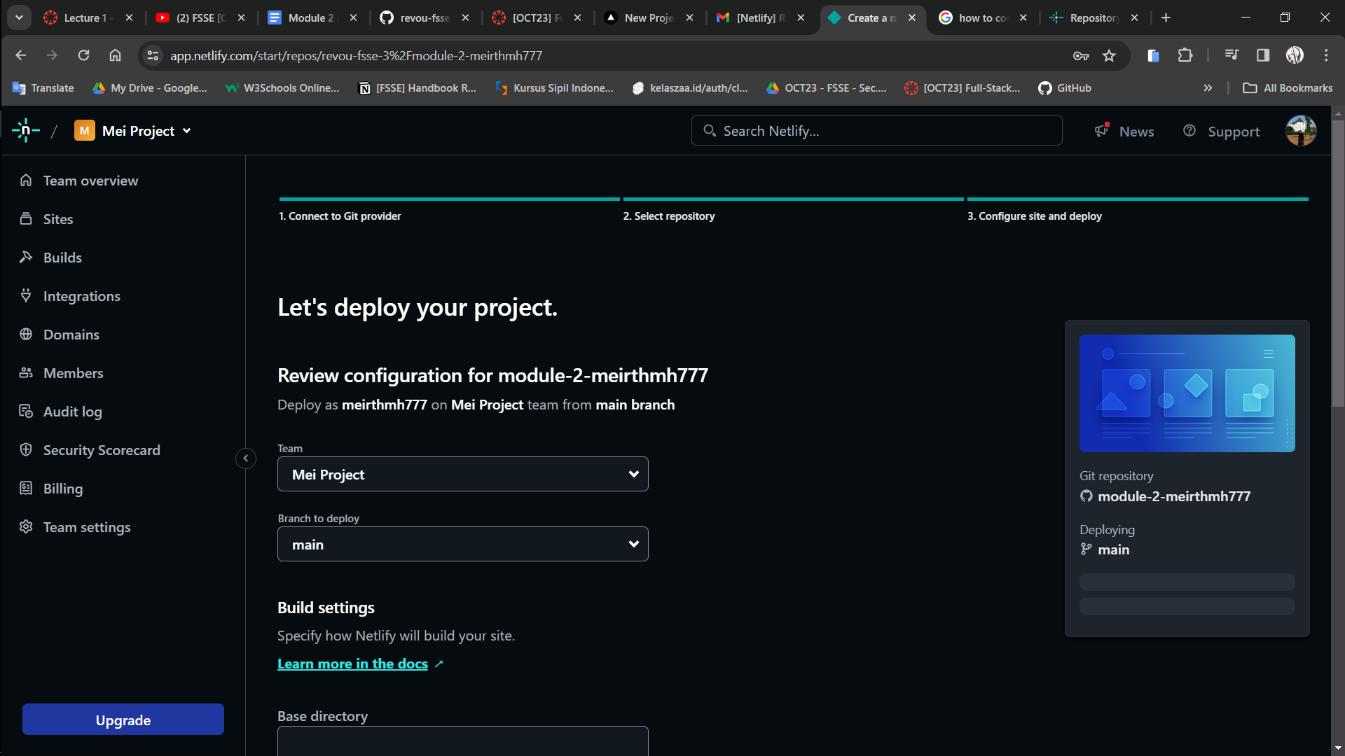

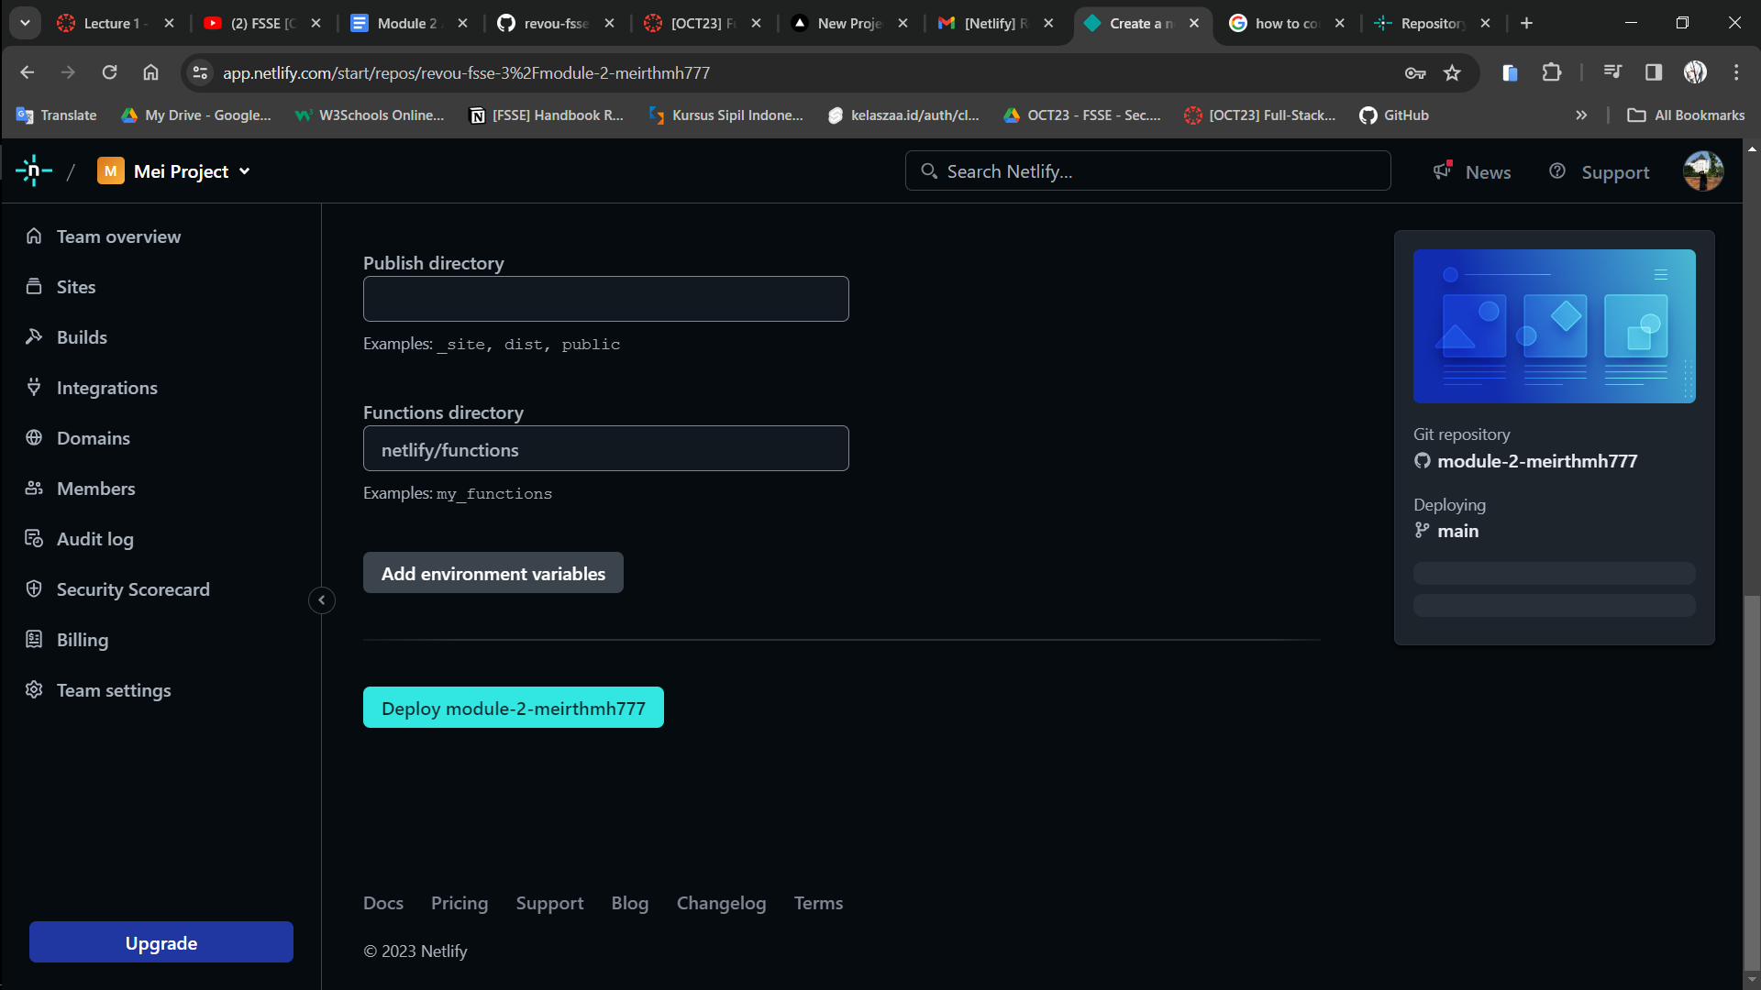

Wait until the deploy process done.

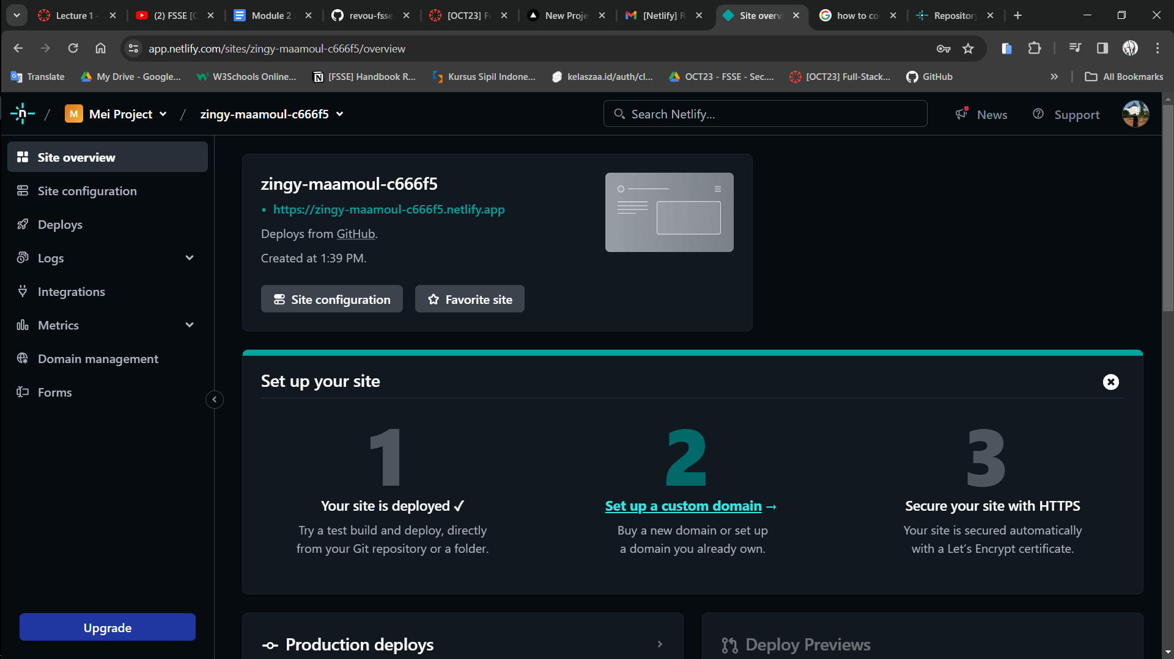

Click the link of your project and make sure your deployment is success.



1. Create a pull request to main branch and merge it after that.

Step 1

Create a new branch using git extension in vscode.

